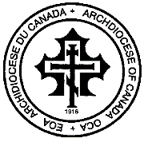
ARCHIVAL METRICAL RECORDS SEARCH

Year of Baptism:

Year of Marriage:

Name of Person: First Name Last Name

Name of Parish & City:

Your name and email address:

Kindly provide as much information as possible and send your request to secretary@archdiocese.ca

FOR YOUR INFORMATION AND GUIDANCE ALL METRICAL RECORDS DATED FROM 1900 – 1965 ARE WRITTEN IN RUSSIAN AND A TRANSLATED COPY WILL BE PROVIDED WITH AUTHENTICITY

A fee of $150 is assessed for searching the metrical records as approved by the Archdiocese of Canada Council Members, October 14, 2018. Payment on our website, www.archdiocese.ca - Canada Helps.org

